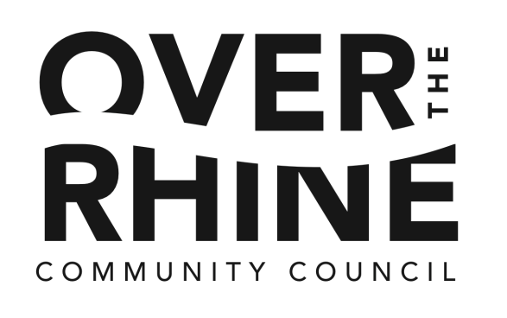
- Call to Order: 6:00

Membership Meeting Agenda
March 28, 2016, 6:00 – 7:30 PM
OTR Recreational Center, 1715 Republic St.
(Entrance and Parking at Race Street)

  - Neighbor Introductions
  - Approval of Agenda
MOTION: To approve agenda as submitted
  - Introduce new Board members to fill 2 vacancies
MOTION: To ratify the selection of new Board members
  - Announce new board opening; submit applications by April 11
  - Update on Elm & Liberty Project

- Trustee Reports: 6:15
  - Approval of consent agenda items:
    - Minutes from last month's membership meeting
    - Treasurer's report
  - Liquor Permits
    - Mr. Pitiful’s: Dave Gronauer/ Robin Faulkner
    - Panda Chef Brunch: Daniel Wells

- Presentations and Reports 6:30
  - Cincinnati Police District 1Report
  - OTR Public Schools
    - Future Plans for Neighborhood Schools: Assistant Superintendent of CPS Bill Myles
    - Rothenberg School: Amber Simpson/Barbara Bell
    - SCPA:
  - Darron Hunter, Community Outreach Advocate, CHRC
  - Kevin Finn, President & CEO, Strategies to End Homelessness
  - Aprina Johnson, OTR Suicide Forum: House of Hope, March 31
  - Kathy L. Boone, Community Engagement Coordinator, The Community Police Partnering Center, Community Policing in OTR
  - Jennifer Arens, Community Education and Volunteer Coordinator, Peaslee Neighborhood Center, Gentrification 101 Forums
  - Cincinnati Transportation Projects – Matt Andrews
    - Liberty St. options
    - Main St. 2-way Open House: April 27 @ Woodward
- Announcements: 7:25
  - April 25 – Monthly Membership Meeting
  - Peter Stackpole, Candidate for Common Pleas Court Judge

- Adjourn 7:30

