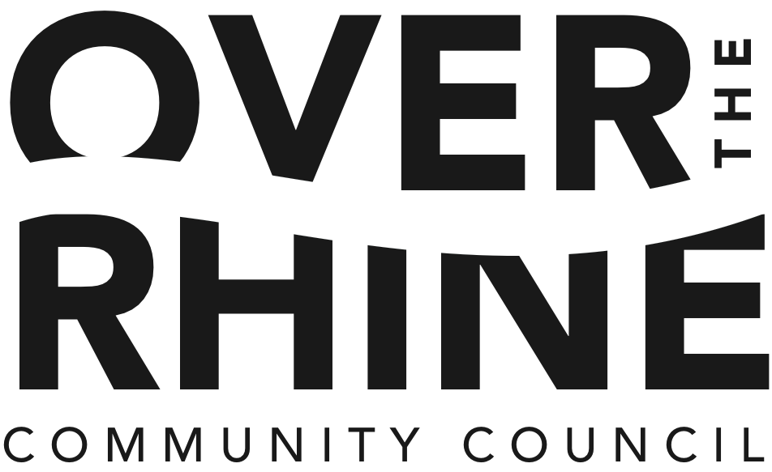

Membership Meeting Agenda

February 22, 6:00 - 7:30 pm

OTR Recreational Center, 1715 Republic Street
(Entrance and Parking at Race Street)

- Over-the-Rhine Housing Study – Community Council Q&A 6:00

- Call to Order: 6:15
  - Approval of Agenda
MOTION: To approve agenda as submitted
- Trustee Reports: 6:20
- Approval of consent agenda items:
  - Minutes from last month's membership meeting
  - Treasurer's report
MOTION: To approve consent items as submitted

- Ratification of Board of Trustees nomination for President
MOTION: Ratify Board of Trustees motion to support this development

- Presentations and Reports 6:30
  - Cincinnati Police District 1 - Captain Lisa Davis
  - Rothenberg School – Amber Simpson/Barbara Bell
  - Liberty Corner at Elm/Liberty
Motion: Support of conceptual plan
  - Mulberry Hill Development Project
Motion: Ratify Board of Trustees motion to support this development
  - Project Court & Spark: Myra Greenberg
  - Metropolitan Sewer District: Mr. Gerald Checco, Director
  - Community Policing Outreach – Kathy Boone

- Adjourn 7:30

