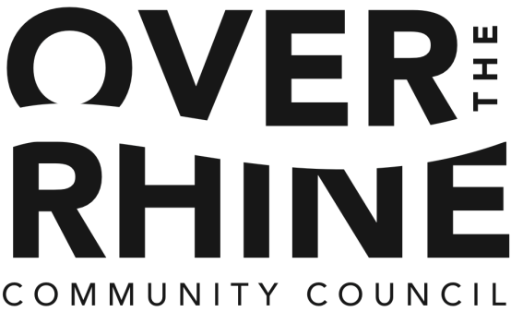

January 28, 2016

Over-the-Rhine Community Housing
114 West 14th Street
Cincinnati, OH 45202

Re: Morgan Apartments – 1900 Vine, 1902-1904 Vine, 2 East McMicken, 53 East Clifton, 19-27 West Clifton

Dear Mrs. Finke,

Following the unanimous vote at our meeting on January 25th, the Over-the-Rhine Community Council is pleased to give our support for Over-the-Rhine Community Housing’s application for 9% Low-Income Housing Tax Credits to the Ohio Housing Finance Agency (OHFA) to fund the rehabilitation of Morgan Apartments, located through-out the Over-the-Rhine neighborhood of Cincinnati, Hamilton County, Ohio.

We understand that if tax credits through OHFA are secured the buildings in Morgan apartments will be rehabilitated, bringing them to a “like-new” condition. The rehabilitation will update the exteriors and interiors of each building. The work will also increase the energy efficiency of the buildings and include universal design components.

It is our belief that this rehabilitation is critical to continue to provide a wide range of housing options within the neighborhood and for the betterment of the community and future residents of Morgan Apartments.

We urge the Ohio Housing Finance Agency to give high priority to this submission so that we can continue to provide safe, secure and affordable housing to families with low incomes in the Over-the-Rhine neighborhood and the Greater Cincinnati Community.

Sincerely,
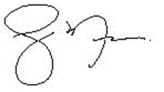
Ryan Messer
President
Over-the-Rhine Community Council

CC: Joan Kaup, Board Secretary

