OTRCC Membership Meeting, November 23, 2015
DRAFT Minutes

Attending: 47

Thanksgiving Dinner provided by Findlay Market Shops and board members. Thank you!

All Board Members attending: Cassandra Barham, Derrick Braziel, Martha Good, Matt Jacob, Joan Kaup, Seth Maney, Matt Manley, Sister Monica McGloin, Ryan Messer, Elizabeth Rodak, Bob Selhorst Amy Silver, John Walter.

Agenda: Add Jim Greenwell/Pendleton Pocket Park issue to the agenda. Modified motion to amend by Mark; seconded by Monica. Motion passed.

Consent Items are Treasurer’s report and the minutes from last month’s meeting. These were sent out on these with the newsletter and were posted on OTRCC website so members can read them at their convenience. Motion by Monica to approve consent items as presented.; seconded by Matt. .Motion passed.

Police Report: Captain Lisa Davis and Sargent Elena Motion introduced two new beat cops: Brendon Rock and Jennifer Shilton.
- Shooting at Phillipus Church and working with Pastor Sam.
- ‘Tis the season for increased theft from autos so remember to lock your junk in the trunk.
- Wallace Duncan has stolen from many OTR stores and was arrested Nov 18 and bond set at $42,000 Court date is Dec 4th.
- 136 E. Clifton is a hot spot. Five hot spots are in District One and our police will spend more time walking, talking and observing and staying in these locations

To contact your local police officers, call 352-4566. Also add to your mobile phone 765-1212 as the non-emergency number for police. Call anytime and report things you observe that concern you.

We owe a debt of gratitude to Officer Tim Eppstein who has served us so long so well.

Rothenberg Report: Miss Simpson, principal, reported they
received donations for the Thanksgiving and are very appreciative of community support. School will be closed Weds, Thurs and Friday. 3rd graders are preparing for the AIR tests, Dec 3 – 7. Winter concert will be at 9 a.m. on Dec 17th. Everyone is welcome!

Dept. of Public Services: Meet new director Maraskeshia Smith who has been the deputy for 6 years.
- Snow season. We can’t use a lot of plows in OTR so we try to pretreat which saves the use/cost of salt. Have been assessing the number of corner cans in OTR. During Dec – March, will try to do an extra clean-up on Fridays as requested and necessary. Report talk tall grass.
- Call 591-6000 to report unsightly areas or request special service. Download a new app called Fix It Cincy to request service.
- Will bike paths on Central Parkway be plowed? Right now we don’t have the right equipment to do so.
- Will be more active asking/warning residents and shop owners to clear their sidewalks.
- Garbage cans need to be moved out of the right away.

Future Leaders OTR: Renae Banks, Program Leader.
Current active topic is inclusion and partnering with Homeless Coalition on a project. Planning a recycling project. The second annual holiday home tour, Dec. 12 & 13, will feature 8 homes. Buy tickets here www.americanlegacytours.com Sending two more children to Germany. Have capacity to enroll a few more youth. Looking for mentors

Neighborhood Support Program (NSP): Mark Manley oversees NSP for OTRCC and reports we have $6800 available through NSP. We did a call out to the community and received several good initiatives. Following is the list of projects and programs the board is suggesting for ratification by full membership
$ 1,050 Insurance
$ 550 OTR Future Leaders Recycling Project
$ 500 OTR Community Festival
$ 2,000 Job Fair
$ 2,000 Flower Pot Program
$ 200 OTR Housing Project
$ 300 Website & newsletter communications
$ 200 Annual appeal through social media
$ 6,800

Bob Selhorst moved to put forth a vote to accept this slate of project; Seth seconded. Motion passed. 23 voted YES. No one voted NO.

Update OTRCC Logo: Residents got together to discuss last year and then Liz Rodak picked up the pieces to finalize the new logo when she joined the board this summer. Everyone has a ballot to vote. Peter Hames feels strongly about the existing logo and chooses not to have a vote and find a way to maintain the existing logo. After discussion, the ballots were collected. The riverside version was selected and Liz will try and incorporate some historical elements from the current

Imagination Alley: OTRCC received an image for Imagination Alley and it clearly connects Vine to to Republic Street with a pedestrian walk through. A presentation will be made at the January membership meeting.
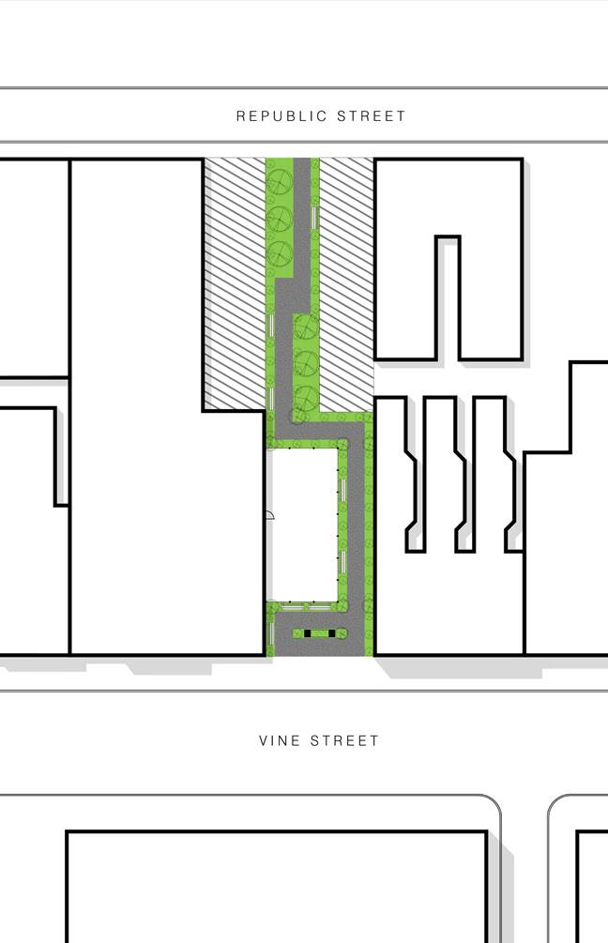

Dept. of Transportation: Matthew Andrews
Main Street: will be two-way from Liberty to 12th.
Liberty Street: It is presently a seven-lane street with 16,000 cars a day, parking, bicycles, pedestrians. Proposed to narrow Liberty Street and add pedestrian crossways. Good discussion. Mathew stayed to talk with residents after the meeting. Review the plan and give your vote and thoughts online at http://www.cincinnati-oh.gov/dote/dote-projects/liberty-sttreet-safety-improvement-study/

St. Francis Seraph Ministries: Chris Schuermann, Executive Director, explains various programs and ministries:
- Soup Kitchen serves 1800 – 2000 a month.
- Bag Lunch Ministry is in Mechanical Café.
- Sara Center empowers women.
- They are working with Findlay Market on their Cooking for the Family Program.
- St Francis School also teaches growing produce and healthy cooking.
They need more room and looking to expand at the corner of Liberty and Republic Streets. The related zoning hearing is Dec. 21.

Announcements:
- Amy Silver, All invited to the next Employment Committee. Please let her know if you prefer Dec 8 or Dec.
- Jim Greenwell, A private individual is trying to purchased a pocket park and convert it to a parking lot located on E. 12th St for $23,000 in a closed process with the city. He has a petition and is asking for signatures to reject the proposal and keep the park as a park. Bonnie Neumeier moved to support and oppose the sale of this park; Seconded by Jack Martin Letter addressed to Planning Commission and Cincinnati Recreation. After discussion. Motion passed.
- Rosalind Fultz from Charlie Winburg’s office invites you to call her anytime at 352-5354 with ideas or concerns abut OTR.
- Cassandra and Ryan will review job opportunities for the street car tomorrow at 3:00 – 5:00 at the Contact Center. Come, Bring resumes.

Meeting adjourned at 7:36.

Next OTRCC Board of Trustee Meeting is the second Monday, December 14, at 6:00 p.m. at the Art Academy.

OTRCC Membership will not hold a meeting in December. Our next OTRCC Membership meeting is the fourth Monday, January 25, 2016 at 6:00 p.m. at the OTR Recreation Center

