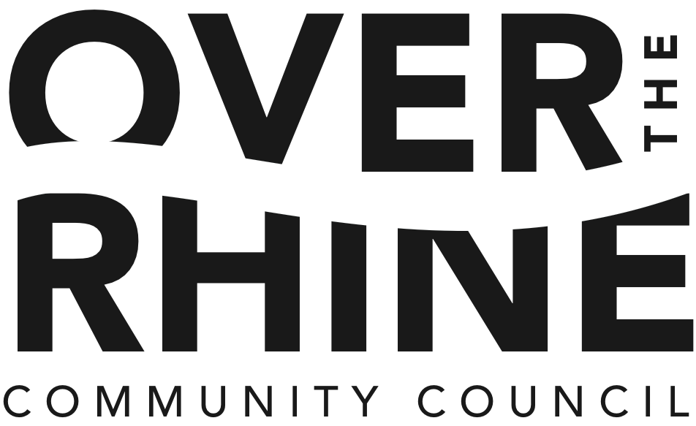

Membership Meeting Agenda

January 25, 6:00 - 7:00 pm Special Session: 7:00-8:00pm

OTR Recreational Center, 1715 Republic Street
(Entrance and Parking at Race Street)

- Call to Order: 6:00
  - Approval of Agenda
MOTION: To approve agenda as submitted
- Trustee Reports: 6:05
- Approval of consent agenda items:
  - Minutes from last month's membership meeting
  - Treasurer's report

- Presentations and Reports 6:10
  - Cincinnati Police District 1 - Captain Lisa Davis
  - Rothenberg School – Amber Simpson/Barbara Bell
  - University of Cincinnati Medical Center – Dr. Analu
  - OTRCH: Development Project Presentation
Motion: Ratify Board of Trustees motion to support this development
  - Cornerstone: Development Project Presentation
Motion: Ratify Board of Trustees motion to support this development
  - Development at Liberty Corner at Elm/Liberty
Motion: Ratify Board of Trustees motion to support this development
  - Streitmann Building Development – Grandin Properties
Motion: Ratify Board of Trustees motion to support this development
  - Republic Street Rooftop Bar
  - Imagination Alley Follow-up – Lann Fields
Motion: Support of revised plans that include neighborhood input
  - Mercer Commons Amendment – Lann Fields
  - Presentation of Findlay Park Enhancements
Motion: Ratify Board of Trustees motion to support this development
  - Protected Bike Lane
Motion: Ratify Board of Trustees motion to support protected bike lane
  - Kresge Foundation Grant Application
Motion: Ratify Board of Trustees motion to support this grant request
- Adjourn 7:00

Special Session:
Over-the-Rhine Housing Inventory Study Neighborhood Report-out 7:00 – 8:00pm

OTR Community Council Meeting Dates, Agenda Items and Event Announcements:
- Future Meeting Dates and Events
  - February Membership Meeting – February 22nd
  - March Membership Meeting – March 28th

