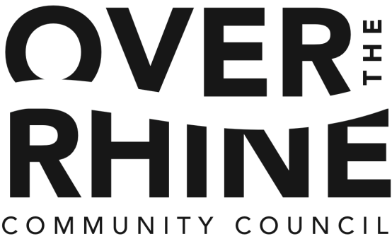

January 28, 2016

Dear Mr. Hampton:
This letter is to show the Over-the-Rhine Community Council's support for the Brewing Heritage Trail, a project of the non-profit Brewery District Community Urban Redevelopment Corporation, and encourage funding this important project.
Cincinnati and Over-the-Rhine's history is an unrivaled resource, and the stories and buildings of its brewing heritage are unmatched anywhere in the country. Preserving and sharing this history through the Brewing Heritage Trail is an important step in making Cincinnati and Over-the-Rhine a destination for local and national visitors, which will be an important economic engine for our neighborhood. The Brewing Heritage Trail is part of the Brewery District Master Plan, which has been approved by the Over-the-Rhine Community Council and City of Cincinnati.
Thank you for your continued hard work on behalf of our neighborhood and city.
Warmest regards,
Ryan L. Messer
President, Over-the-Rhine Community Council

CC: Joan Kaup, Board Secretary

