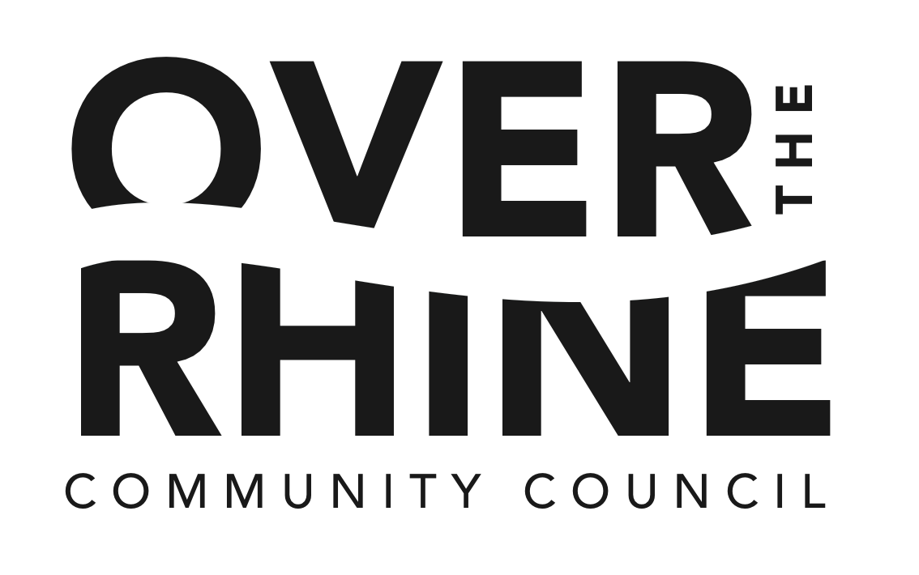
AGENDA

Over-the-Rhine Community Council
Board of Trustees - Monthly Meeting
Art Academy of Cincinnati
January 11, 2016
6:00-7:30pm

Board Members Present
Time | Item | Owner
6:00 | Welcome & Opening Remarks | Ryan
6:10 | Presentations  - OTRCH: Development Project Presentation  - Cornerstone: Development Project Presentation  - Development at Liberty Corner at Elm/Liberty  - Streitmann Building Development – Grandin Properties
6:40 | Secretary Report (Minutes, Action Items) | Joan
6:45 | Treasurer Report  - NSP (Mark) | Matt
6:50 | Vice President  - Liquor permits & updates | Seth
6:55 | President Report  - OTR Parking Plan  - Update on Jordan Market  - Open Board Position | Ryan
7:10 | Work Plan Updates by Report – High level recap  - Employment  - Schools  - Safety & Blight  - Balanced Development | Co-Chairs
7:25 | Announcements | All
7:30 | Adjournment | Ryan

